FEASIBILITY REPORT
FEASIBILITY REPORT
TECHNICAL FEASIBILITY:
Evaluating the technical feasibility is the trickiest part of a feasibility study. This is because, at this point in time, not too many detailed design of the system, making it difficult to access issues like performance, costs on (on account of the kind of technology to be deployed) etc. A number of issues have to be considered while doing a technical analysis.
- Understand the different technologies involved in the proposed system:
Before commencing the project, we have to be very clear about what are the technologies that are to be required for the development of the new system.
- Find out whether the organization currently possesses the required technologies:
  - Is the required technology available with the organization?
  - If so is the capacity sufficient?
For instance –
“Will the current printer be able to handle the new reports and forms required for the new system?”
OPERATIONAL FEASIBILITY:
Proposed projects are beneficial only if they can be turned into information systems that will meet the organizations operating requirements. Simply stated, this test of feasibility asks if the system will work when it is developed and installed. Are there major barriers to Implementation? Here are questions that will help test the operational feasibility of a project:
- Is there sufficient support for the project from management from users? If the current system is well liked and used to the extent that persons will not be able to see reasons for change, there may be resistance.
- Are the current business methods acceptable to the user? If they are not, Users may welcome a change that will bring about a more operational and useful systems.
- Have the user been involved in the planning and development of the project?
- Early involvement reduces the chances of resistance to the system and in
- General and increases the likelihood of successful project.
Since the proposed system was to help reduce the hardships encountered. In the existing manual system, the new system was considered to be operational feasible.
ECONOMIC FEASIBILITY:
Economic feasibility attempts 2 weigh the costs of developing and implementing a new system, against the benefits that would accrue from having the new system in place. This feasibility study gives the top management the economic justification for the new system.
A simple economic analysis which gives the actual comparison of costs and benefits are much more meaningful in this case. In addition, this proves to be a useful point of reference to compare actual costs as the project progresses. There could be various types of intangible benefits on account of automation. These could include increased customer satisfaction, improvement in product quality better decision making timeliness of information, expediting activities, improved accuracy of operations, better documentation and record keeping, faster retrieval of information, better employee morale.

SYSTEM REQUIREMENT SPECIFICATION

OVERVIEW
Application For File Sharing System aims at providing and receiving of digital files over a network allowing multiple users to access the same file on priority level basis among the available users of the system.
Application For File Sharing System is a concept of public or private sharing of computer data or space in a network with various levels of access privileges. While files can easily be shared outside a network (for example, simply by handling or mailing someone your file), the term Application For File Sharing System almost always means sharing files in a network, even if in a small local area network. Application For File Sharing System allows a number of people to use the same file. Application For File Sharing System can also mean having an allocated amount of personal file storage in a common file system. It enables to create a central repository for organizing our folders. Within these folders we can create our own folders and we can upload our files into it. Application For File Sharing System provides a file management with secure access control, sharing and supporting File with in the registered users.

STUDY OF THE SYSTEM
In the flexibility of uses the interface has been developed a graphics concepts in mind, associated through a browser interface. The GUI’s at the top level has been categorized as follows
- Administrator Interface Design.
- User Interface.
- Security Authentication.
- Reports.
- General end-users.
The administrative user interface will maintain the different users details, the interface helps the administration with all the transactional states like which files is owner of the which file, data usage history of the users, users details information history. And the statistics of the system in difference strategies.

NUMBER OF MODULES
The system after careful analysis has been identified to be presented with the following modules:
The Modules involved are
- Authentication and Security Module
- Users Module
- File Management Module
- Admin Module
- Reports Module

MODULES DESCRIPTION
- Authentication and Security Module

The user details should be verified against the details in the user tables and if it is valid user, they should be entered into the system. Once entered, based on the user type access to the different modules to be enabled / disabled.

- User Module

This module consists of the following sub modules
- Registration Module
The general users who can use the application their personal information, contact information and other information etc…

- Users Management Module
The Users can access their account information and they can view the details of their personal information and contact details. The Users can modify the personal and contact details of their in this module

- File Management Module
This module has following sub modules
- Folders Management Module:

In this module folder creation and maintenance, sub folder creation, deletion and managing the folder, the uploaded file can transfer from one folder to other folders.
- File Upload Management Module:

The file uploading and managing the file will come in this module. The files accessibility privileges, information about the files size, type of the files, name of the files and memory management for file uploading and file deletion etc.
- File Download Management Module

In this module the file downloads and storing it in to their system. the downloaded file information stores in the database. The files accessibility privilege and information of the accessibility given users details, information about the files size, type of the files, name of the files etc

- Admin Module

The Administrator is a main part of an organization that he may organize all the Users and their folders information. This administrator plays the main role in this system, here we are considering he should maintain all Users profile details(address, contact, etc,….),on the user request to modify his/her (user) profile like address, phone number etc. He can also view the entire Users list.
The Administrator will maintain entire Users account history, folders history file history, and the Administrator can generate the reports like number of Users registered on the date bases reports etc..

- Reports Module:

In this Module the User and Administrator can generate the different types of Reports according to their access. The User can generate the Report like how many no of other Users downloaded the Uploaded File and User can view their details, etc.
The Administrator can generate the Report like at present how many users are logged In , Number of Users are using the application and date wise registration Reports, etc.

PROCESS FLOW

ARCHITECTURE DIAGRAM

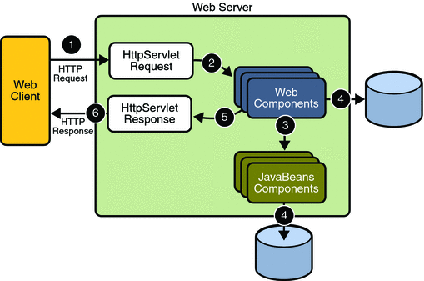

- THE PRESENTATION LAYER
Also called as the client layer comprises of components that are dedicated to presenting the data to the user. For example: Windows/Web Forms and buttons, edit boxes, Text boxes, labels, grids, etc.
- THE BUSINESS RULES LAYER
This layer encapsulates the Business rules or the business logic of the encapsulations. To have a separate layer for business logic is of a great advantage. This is because any changes in Business Rules can be easily handled in this layer. As long as the interface between the layers remains the same, any changes to the functionality/processing logic in this layer can be made without impacting the others. A lot of client-server apps failed to implement successfully as changing the business logic was a painful process

- THE DATA ACCESS LAYER
This layer comprises of components that help in accessing the Database. If used in the right way, this layer provides a level of abstraction for the database structures. Simply put changes made to the database, tables, etc do not affect the rest of the application because of the Data Access layer. The different application layers send the data requests to this layer and receive the response from this layer.
- THE DATABASE LAYER
This layer comprises of the Database Components such as DB Files, Tables, Views, etc. The Actual database could be created using SQL Server, Oracle, Flat files, etc.
In an n-tier application, the entire application can be implemented in such a way that it is independent of the actual Database. For instance, you could change the Database Location with minimal changes to Data Access Layer. The rest of the Application should remain unaffected.

SDLC METHODOLOGIES

This document play a vital role in the development of life cycle (SDLC) as it describes the complete requirement of the system. It means for use by developers and will be the basic during testing phase. Any changes made to the requirements in the future will have to go through formal change approval process.
SPIRAL MODEL was defined by Barry Boehm in his 1988 article, “A spiral Model of Software Development and Enhancement. This model was not the first model to discuss iterative development, but it was the first model to explain why the iteration models.
As originally envisioned, the iterations were typically 6 months to 2 years long. Each phase starts with a design goal and ends with a client reviewing the progress thus far. Analysis and engineering efforts are applied at each phase of the project, with an eye toward the end goal of the project.
The steps for Spiral Model can be generalized as follows:
- The new system requirements are defined in as much details as possible. This usually involves interviewing a number of users representing all the external or internal users and other aspects of the existing system.
- A preliminary design is created for the new system.
- A first prototype of the new system is constructed from the preliminary design. This is usually a scaled-down system, and represents an approximation of the characteristics of the final product.
- A second prototype is evolved by a fourfold procedure:
- Evaluating the first prototype in terms of its strengths, weakness, and risks.
- Defining the requirements of the second prototype.
- Planning an designing the second prototype.
- Constructing and testing the second prototype.
- At the customer option, the entire project can be aborted if the risk is deemed too great. Risk factors might involved development cost overruns, operating-cost miscalculation, or any other factor that could, in the customer’s judgment, result in a less-than-satisfactory final product.
- The existing prototype is evaluated in the same manner as was the previous prototype, and if necessary, another prototype is developed from it according to the fourfold procedure outlined above.
- The preceding steps are iterated until the customer is satisfied that the refined prototype represents the final product desired.
- The final system is constructed, based on the refined prototype.
- The final system is thoroughly evaluated and tested. Routine maintenance is carried on a continuing basis to prevent large scale failures and to minimize down time.

The following diagram shows how a spiral model acts like:

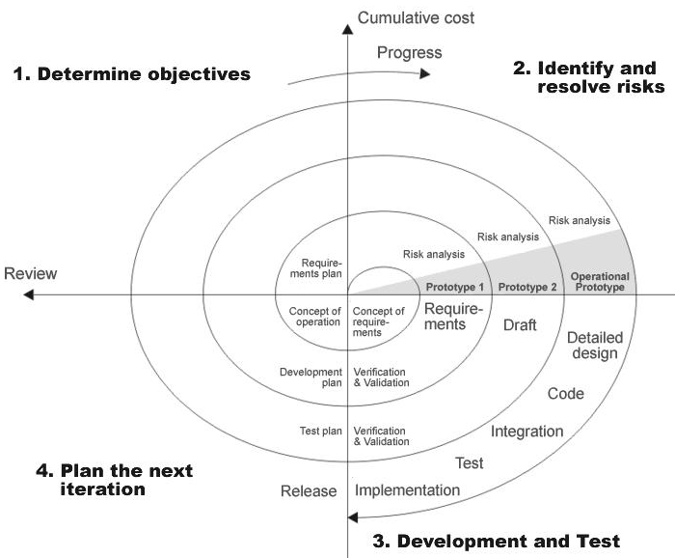

Fig 1.0-Spiral Model

ADVANTAGES
- Estimates(i.e. budget, schedule etc .) become more relistic as work progresses, because important issues discoved earlier.
- It is more able to cope with the changes that are software development generally entails.
- Software engineers can get their hands in and start woring on the core of a project earlier.

SOFTWARE REQUIREMENT AND
HARDWARE REQUIREMENT

SOFTWARE REQUIREMENTS

Operating System : Windows XP/2003 or Linux
User Interface : HTML, CSS
Client-side Scripting : JavaScript
Programming Language : Java
Web Applications : JDBC, Servlets, JSP
IDE/Workbench : My Eclipse 6.0
Database : Oracle 10g
Server Deployment : Tomcat 5.x

HARDWARE REQUIREMENTS
Processor : Pentium IV
Hard Disk : 40GB
RAM : 512MB or more

SYSTEM DESIGN

DATA FLOW DIAGRAMS

Data Flow Diagrams:

A graphical tool used to describe and analyze the moment of data through a system manual or automated including the process, stores of data, and delays in the system. Data Flow Diagrams are the central tool and the basis from which other components are developed. The transformation of data from input to output, through processes, may be described logically and independently of the physical components associated with the system. The DFD is also know as a data flow graph or a bubble chart.
DFDs are the model of the proposed system. They clearly should show the requirements on which the new system should be built. Later during design activity this is taken as the basis for drawing the system’s structure charts. The Basic Notation used to create a DFD’s are as follows:
1. Dataflow: Data move in a specific direction from an origin to a destination.

2. Process: People, procedures, or devices that use or produce (Transform) Data. The physical component is not identified.

3. Source: External sources or destination of data, which may be People, programs, organizations or other entities.

4. Data Store: Here data are stored or referenced by a process in the System.

Context Level Data Flow Diagram

SYSTEM LEVEL CONTEXT DIAGRAM:

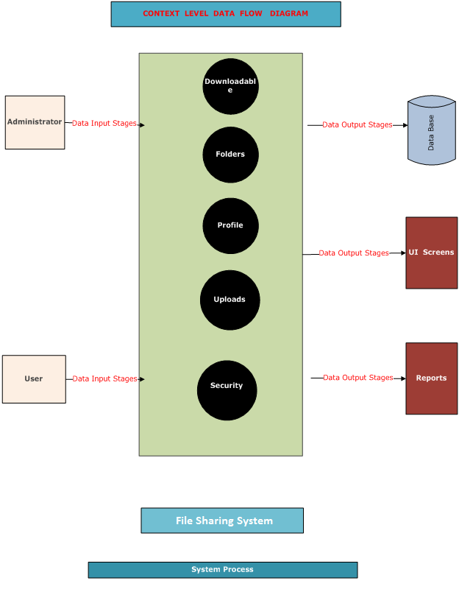

LEVEL-1 DFD

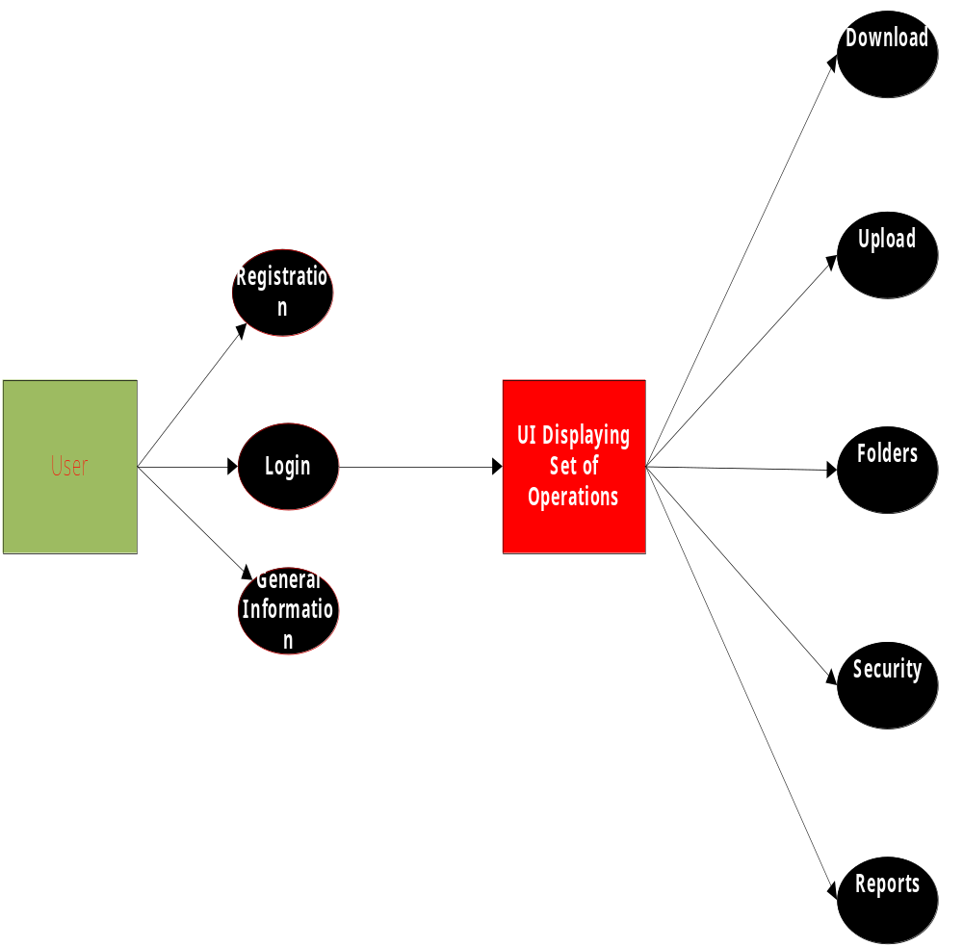

AUTHENTICATION DFD:

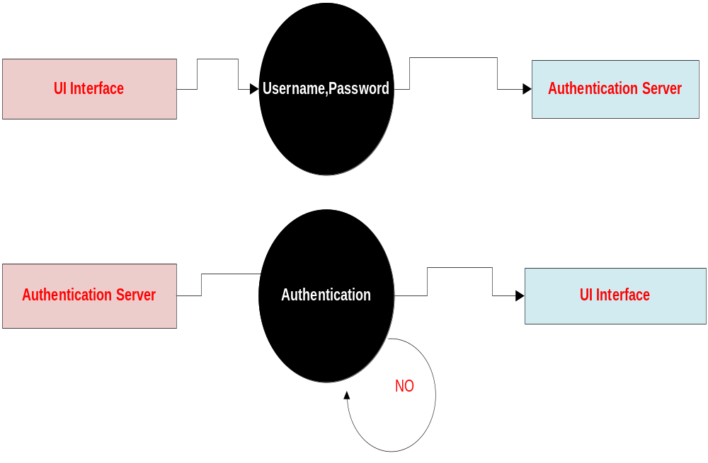

Administrator Context Level DFD

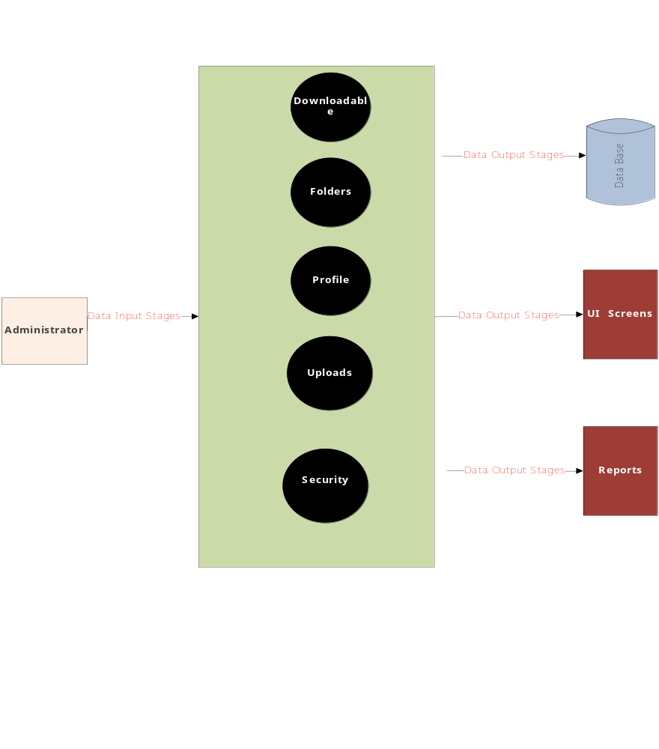

Level 1.0:-

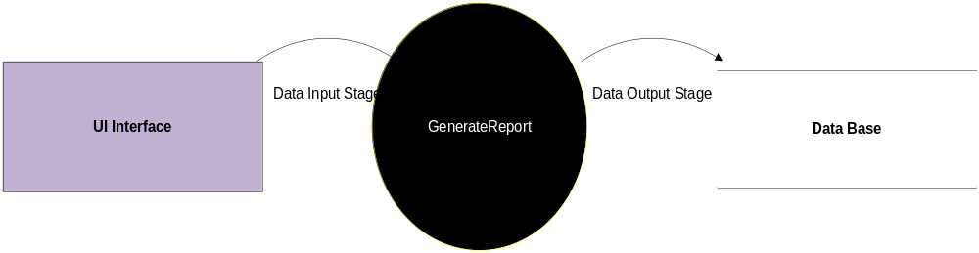

Level 1.0.1:-

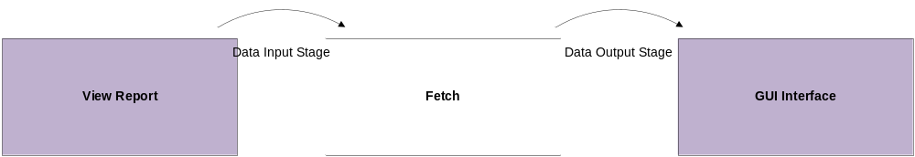

Level 1.1:-

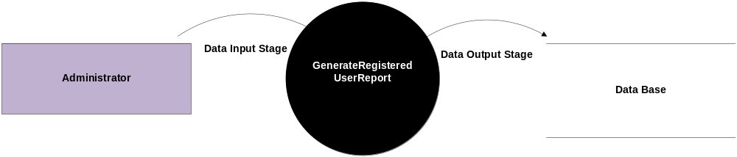

Level 1.1.0:-
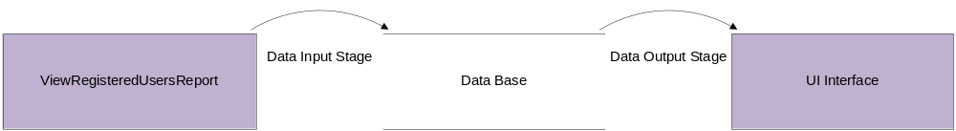

Level 1.2:-
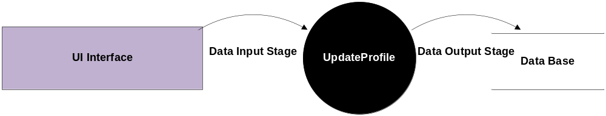

User Context Level DFD 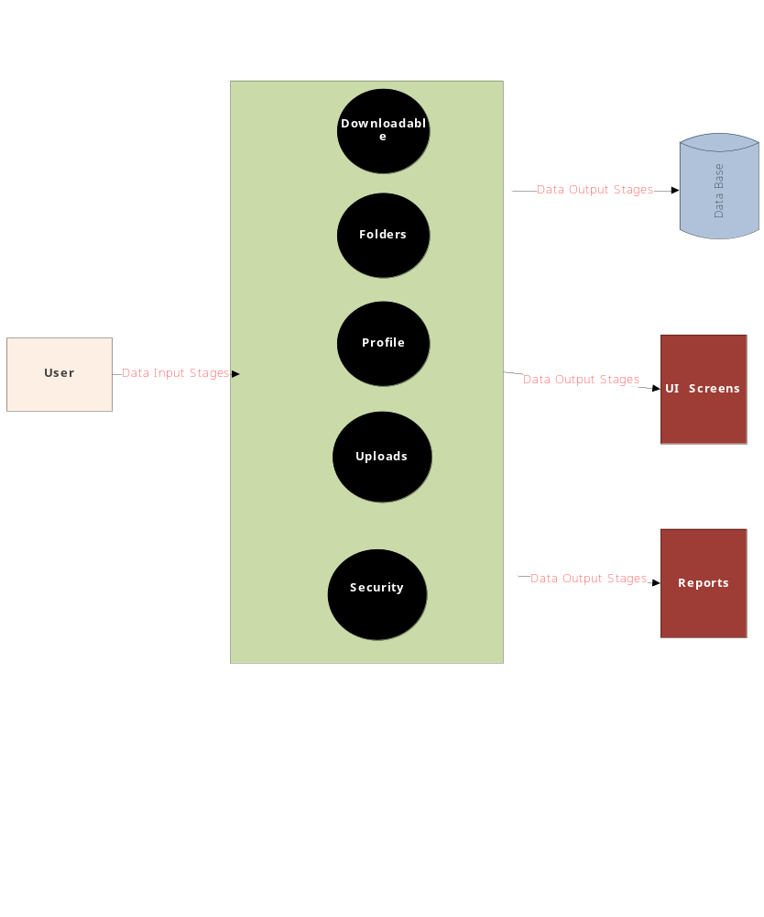

Level 1.0:-

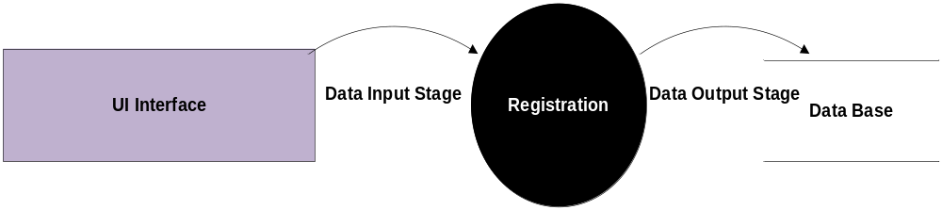

Level 1.1:-
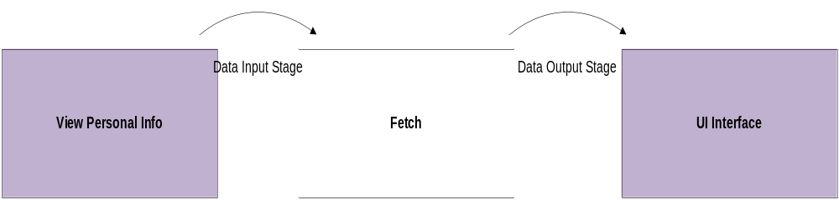

Level 1.2:-

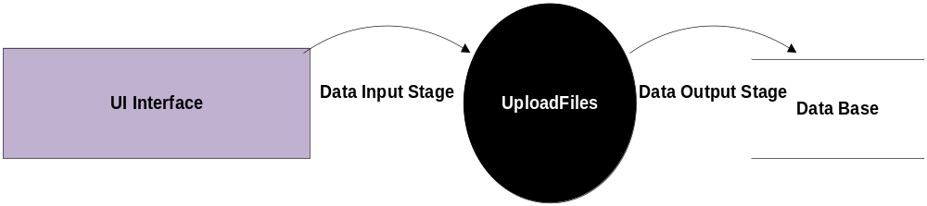

Level 1.3:-

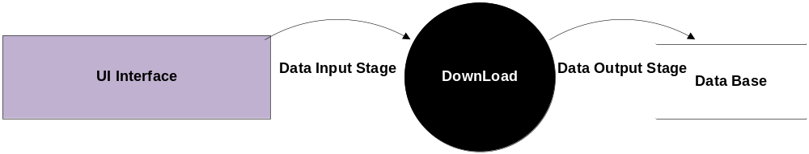

Level-1.0.1 Diagram:

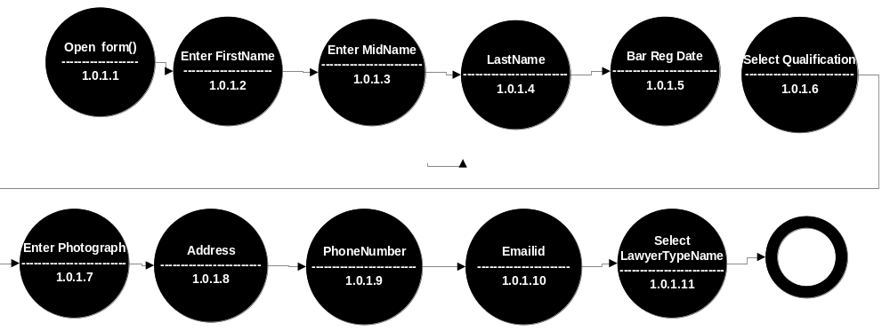

E-R DIAGRAM

E-R Diagram
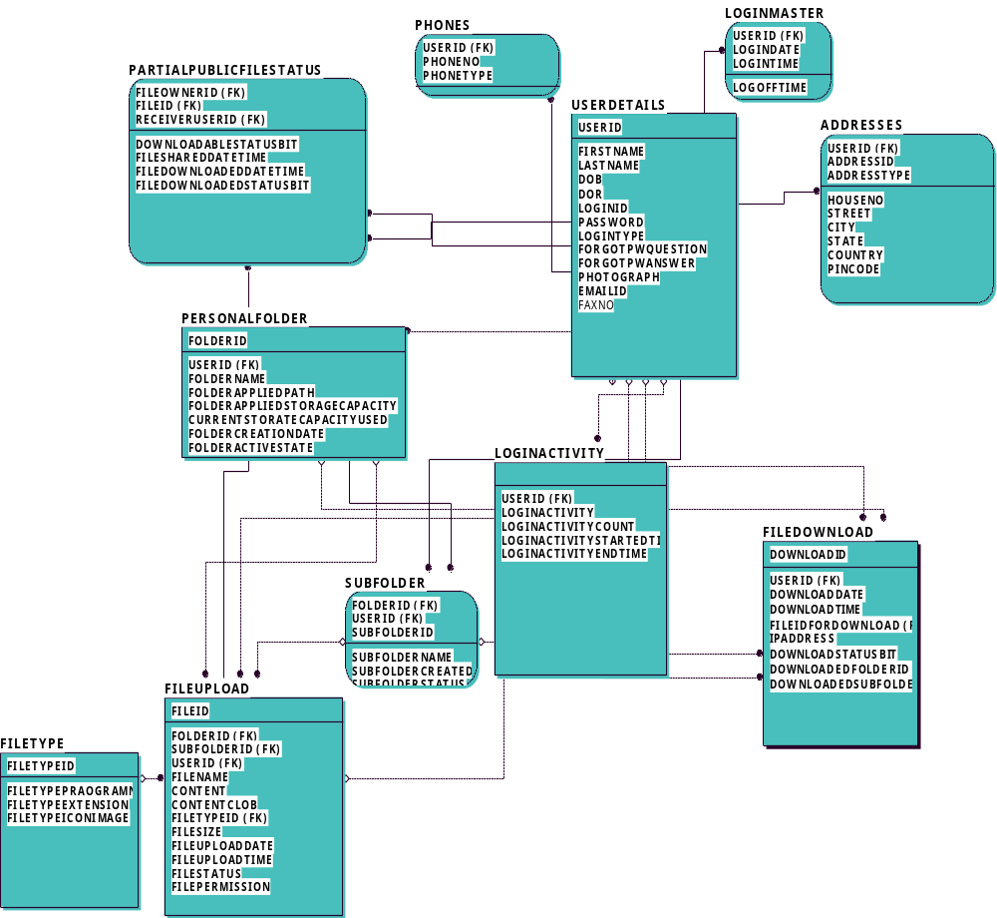

UML DIAGRAMS

UNIFIED MODELING LANGUAGE DIAGRAMS
The unified modeling language allows the software engineer to express an analysis model using the modeling notation that is governed by a set of syntactic semantic and pragmatic rules.

A UML system is represented using five different views that describe the system from distinctly different perspective. Each view is defined by a set of diagram, which is as follows.

USER MODEL VIEW
This view represents the system from the users perspective.
The analysis representation describes a usage scenario from the end-users perspective.

STRUCTURAL MODEL VIEW
In this model the data and functionality are arrived from inside the system.
This model view models the static structures.

BEHAVIORAL MODEL VIEW
It represents the dynamic of behavioral as parts of the system, depicting the interactions of collection between various structural elements described in the user model and structural model view.

IMPLEMENTATION MODEL VIEW
In this the structural and behavioral as parts of the system are represented as they are to be built.
ENVIRONMENTAL MODEL VIEW
In this the structural and behavioral aspects of the environment in which the system is to be implemented are represented.

UML is specifically constructed through two different domains they are:
UML Analysis modeling, which focuses on the user model and structural model views of the system.
UML design modeling, which focuses on the behavioral modeling, implementation modeling and environmental model views.

Use case Diagrams represent the functionality of the system from a user’s point of view. Use cases are used during requirements elicitation and analysis to represent the functionality of the system. Use cases focus on the behavior of the system from external point of view.

Actors are external entities that interact with the system. Examples of actors include users like administrator, bank customer …etc., or another system like central database.

Class Diagram

CLASS DIAGRAM
Class diagrams describe the structure of the system in terms of classes and objects. The servlet api class diagram will be as follows.

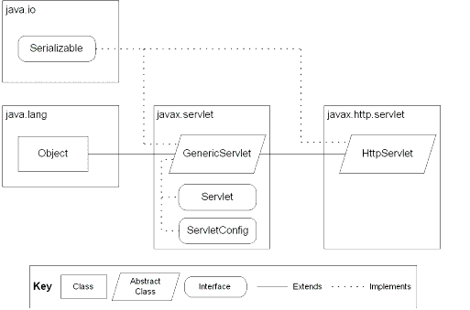
JSP: Implicit Objects

Class Collaboration Diagrams

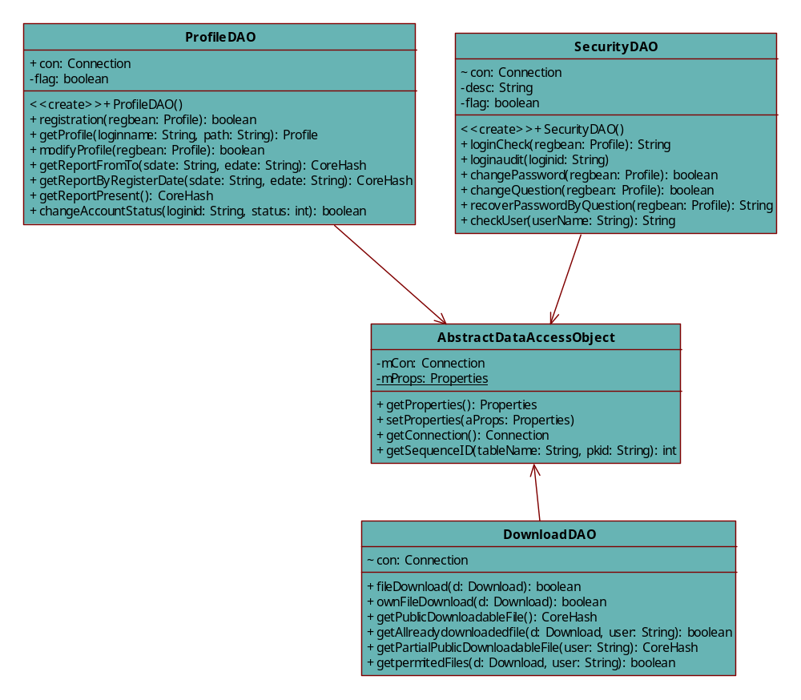
Class Collaborative Diagrams:

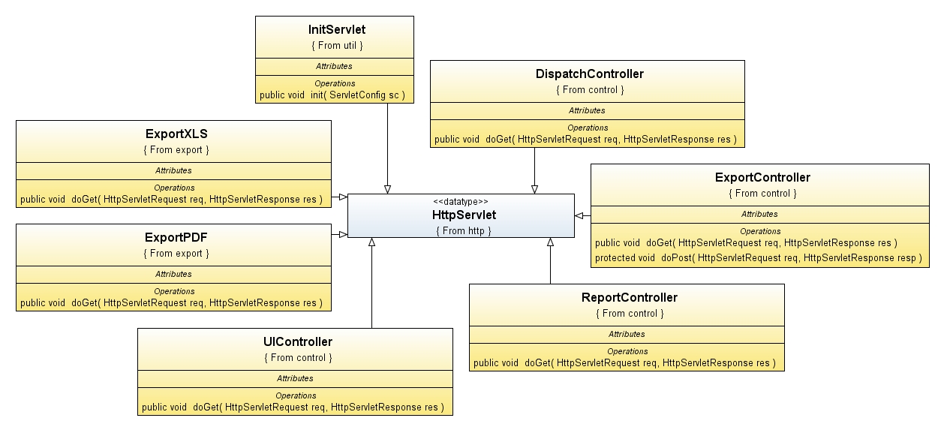

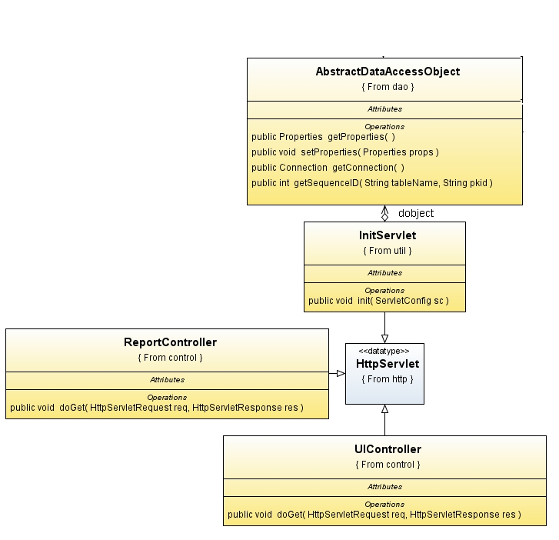

Use Case Diagrams

UML Diagrams
Unified Modeling Language:

The Unified Modeling Language allows the software engineer to express an analysis model using the modeling notation that is governed by a set of syntactic semantic and pragmatic rules.

A UML system is represented using five different views that describe the system from distinctly different perspective. Each view is defined by a set of diagram, which is as follows.
  - User Model View
    - This view represents the system from the users perspective.
    - The analysis representation describes a usage scenario from the end-users perspective.

  - Structural model view
    - In this model the data and functionality are arrived from inside the system.
    - This model view models the static structures.

- Behavioral Model View
It represents the dynamic of behavioral as parts of the system, depicting the interactions of collection between various structural elements described in the user model and structural model view.

- Implementation Model View
In this the structural and behavioral as parts of the system are represented as they are to be built.

- Environmental Model View
In this the structural and behavioral aspects of the environment in which the system is to be implemented are represented.

UML is specifically constructed through two different domains they are:
- UML Analysis modeling, this focuses on the user model and structural model views of the system.
- UML design modeling, which focuses on the behavioral modeling, implementation modeling and environmental model views.

Use case Diagrams represent the functionality of the system from a user’s point of view. Use cases are used during requirements elicitation and analysis to represent the functionality of the system. Use cases focus on the behavior of the system from external point of view.

Actors are external entities that interact with the system. Examples of actors include users like administrator, bank customer …etc., or another system like central database.

Use Case Diagram
- System Diagram:

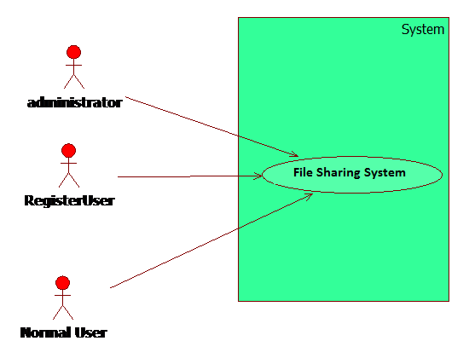

2.Administrator:
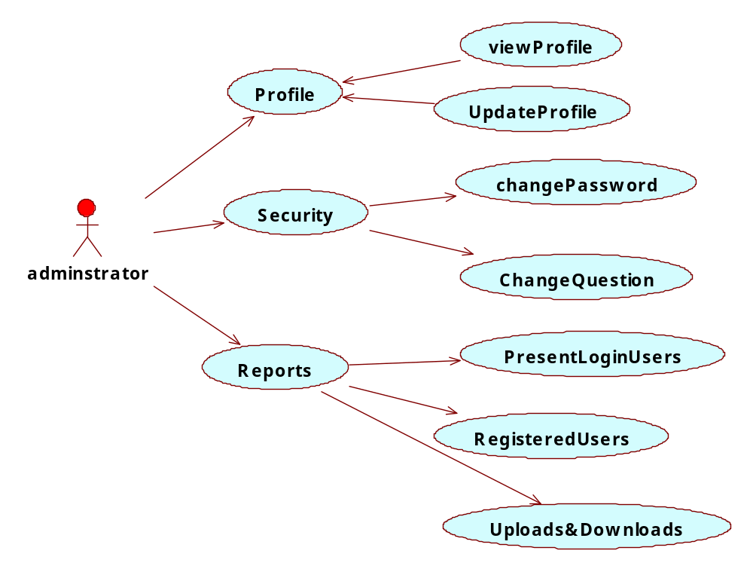

3.RegisterUser:
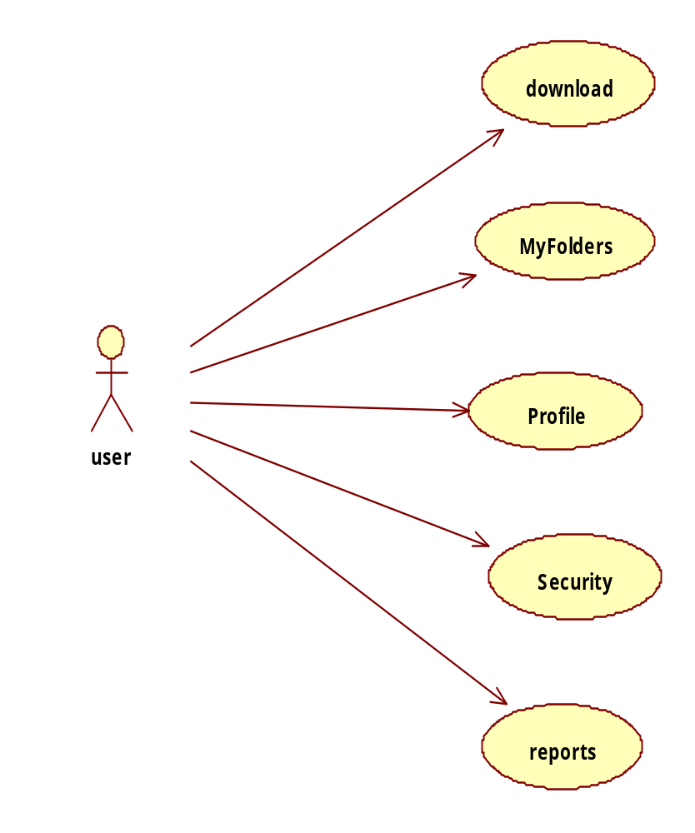

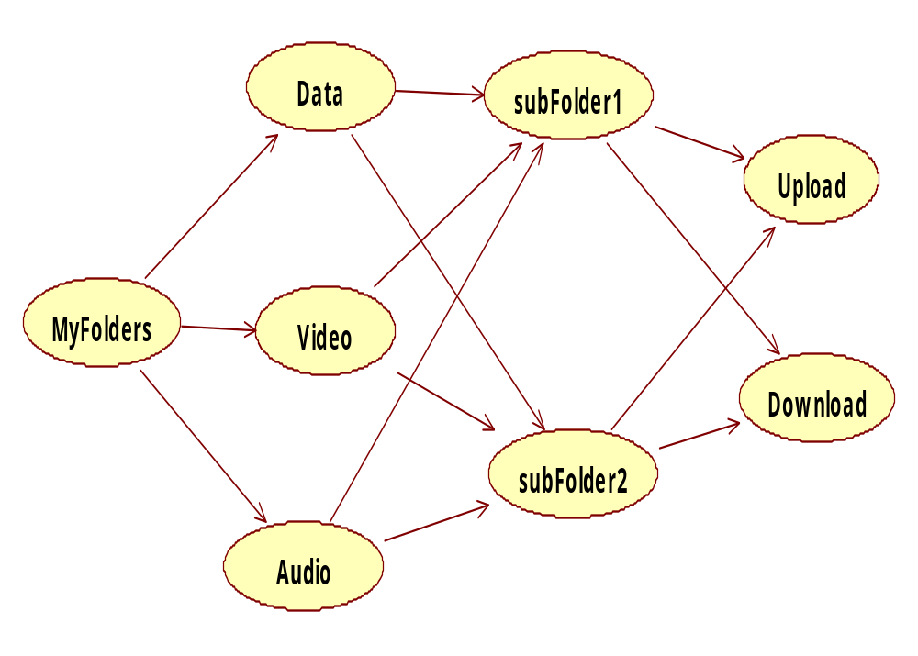

4.Normal User
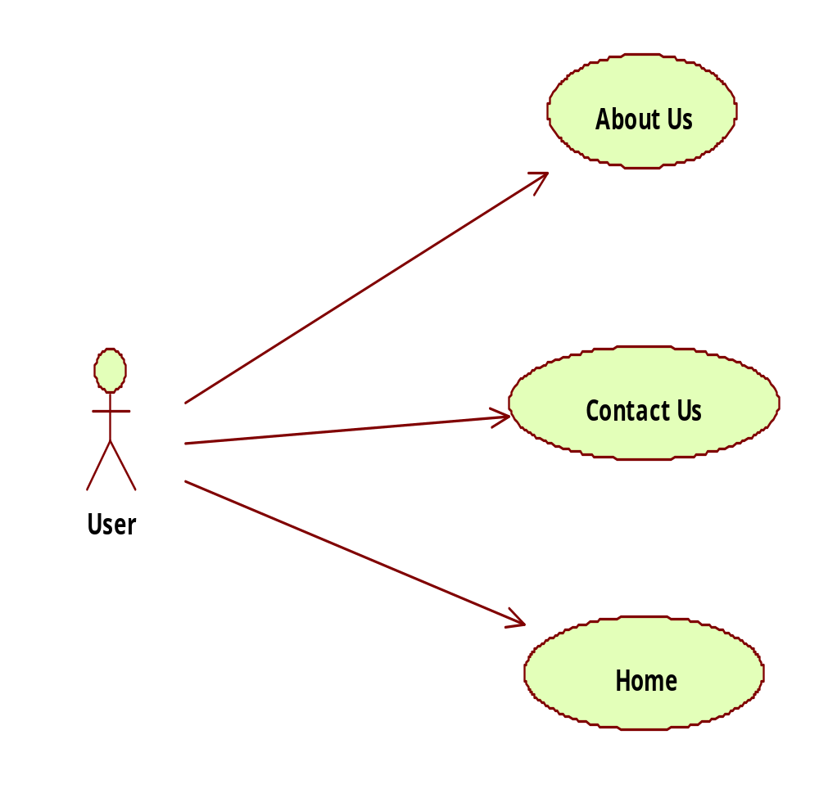

Sequence Diagrams

Sequence Diagram
User
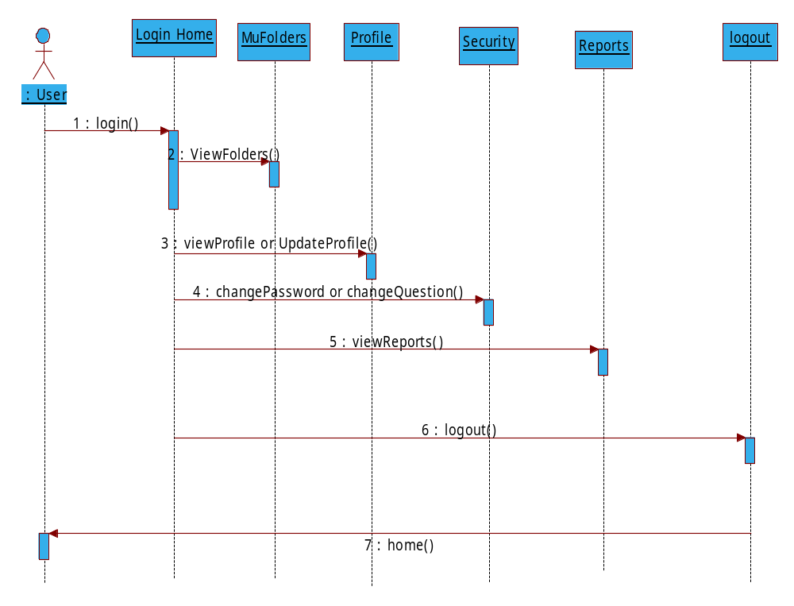

Administrator
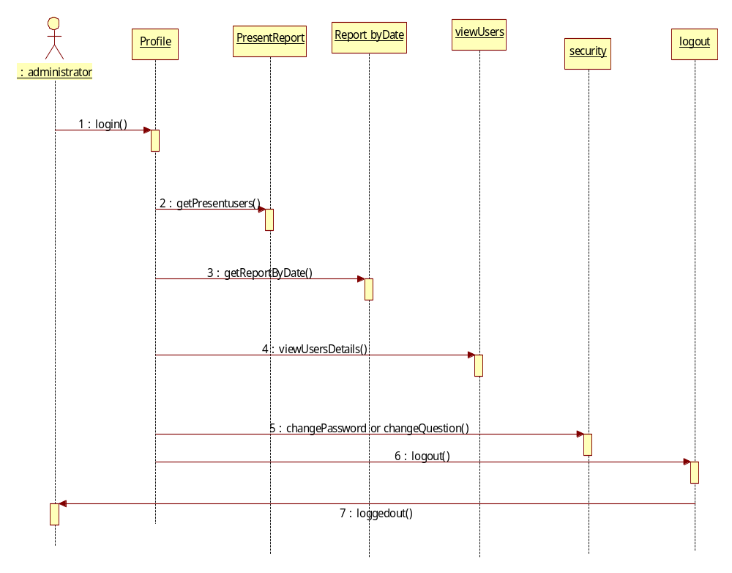

Operational level
Sequence & Collaboration Diagrams

Operational level Sequence Diagrams
- Login Sequence Diagram
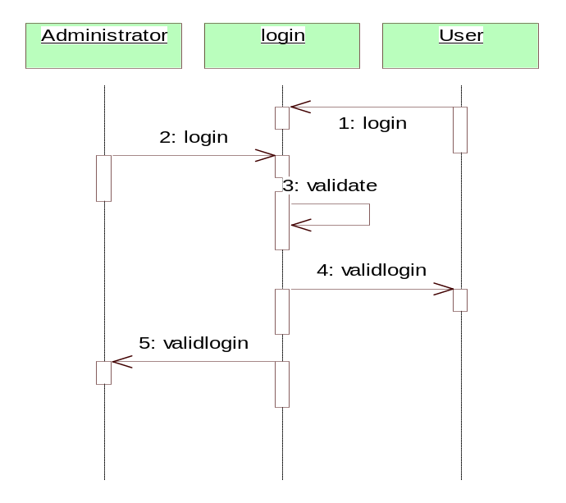
Login Collaborative Diagram
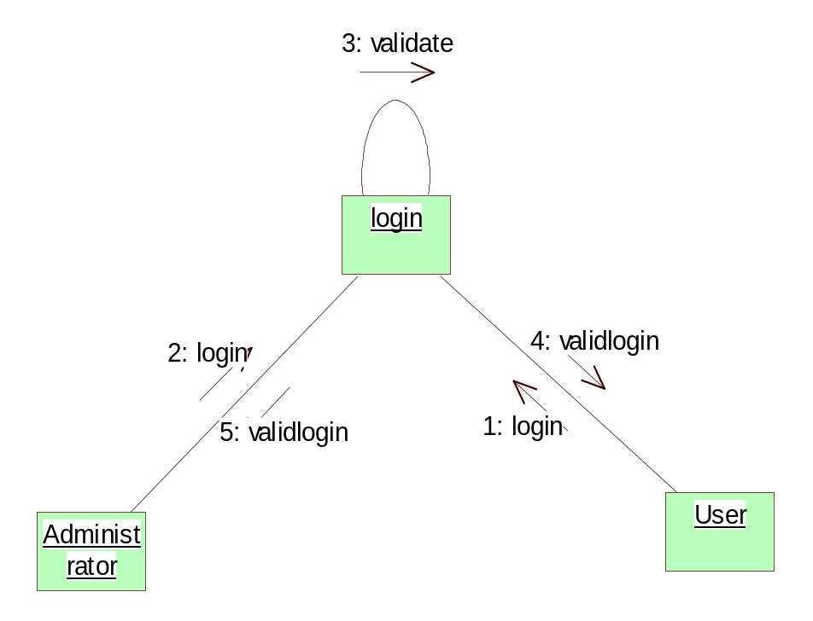

- Upload Sequence Diagram
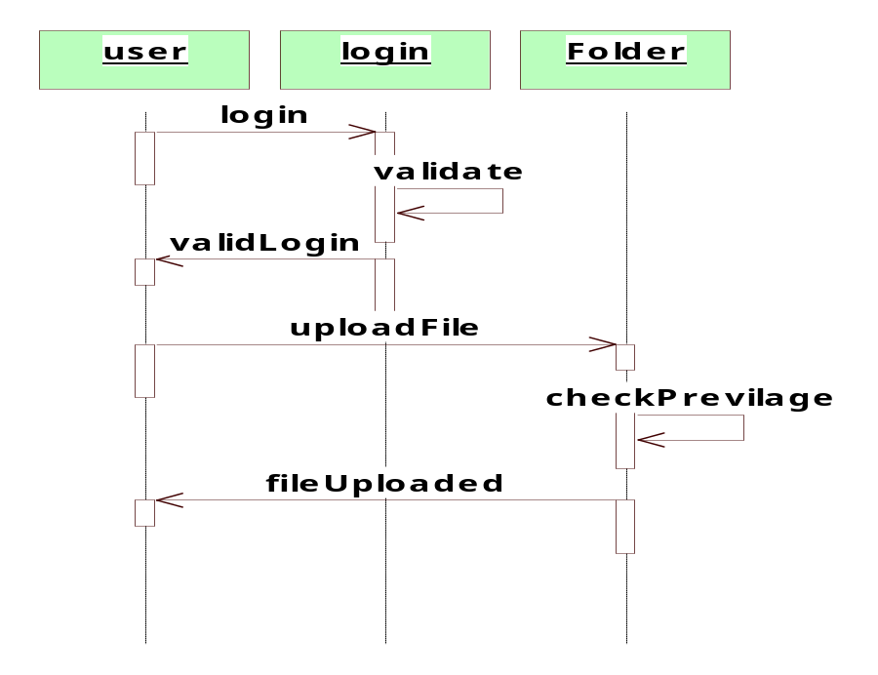
Upload Collaborative Diagram
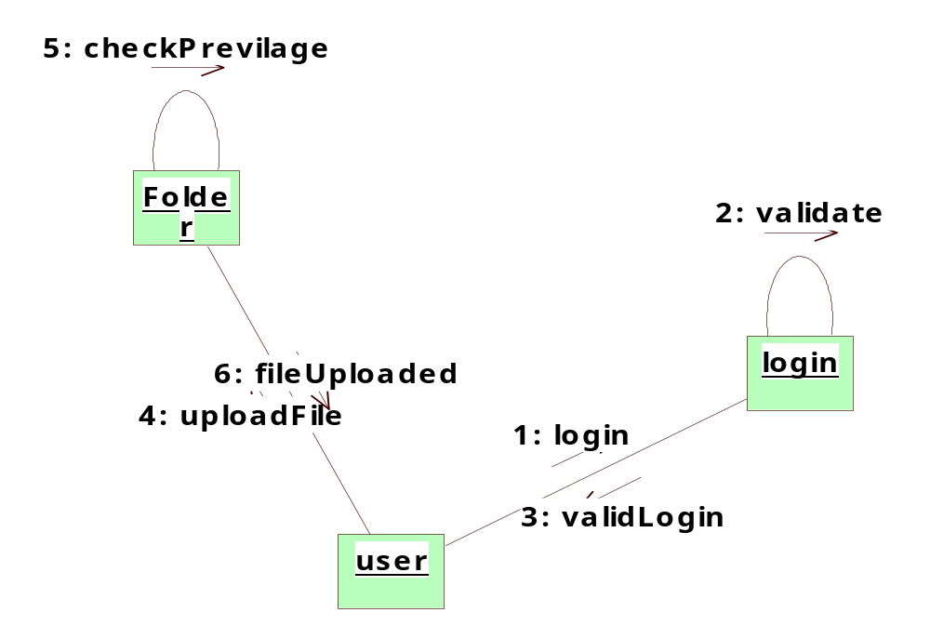
- Download Sequence Diagram
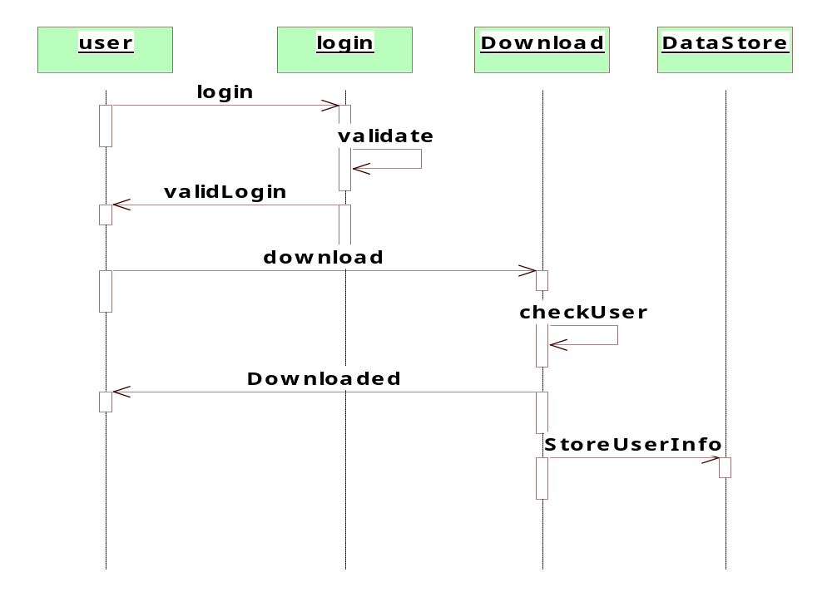
Download Sequence Diagram
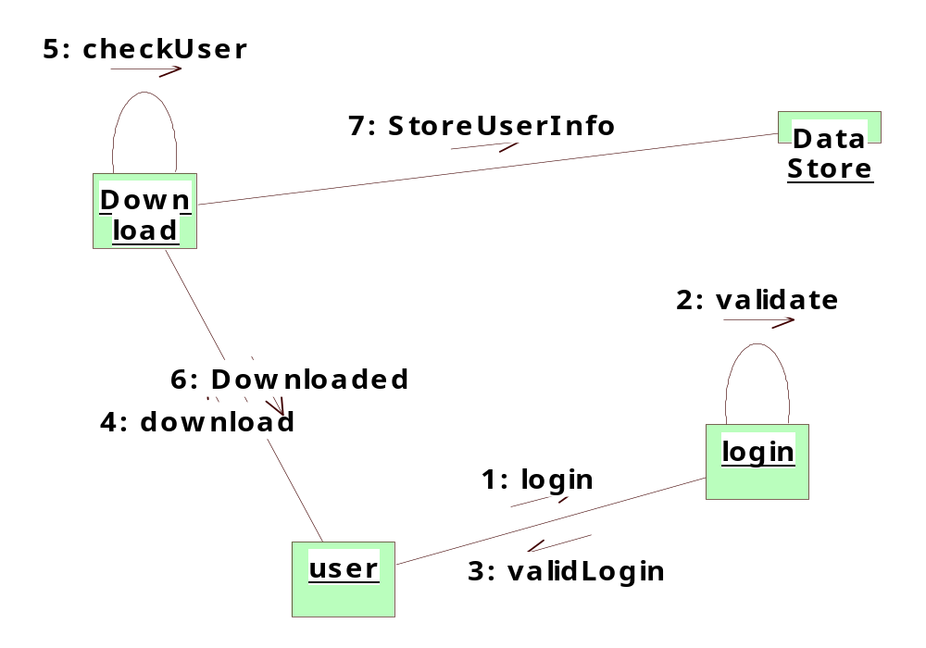
- Present Login User Report Sequence Diagram
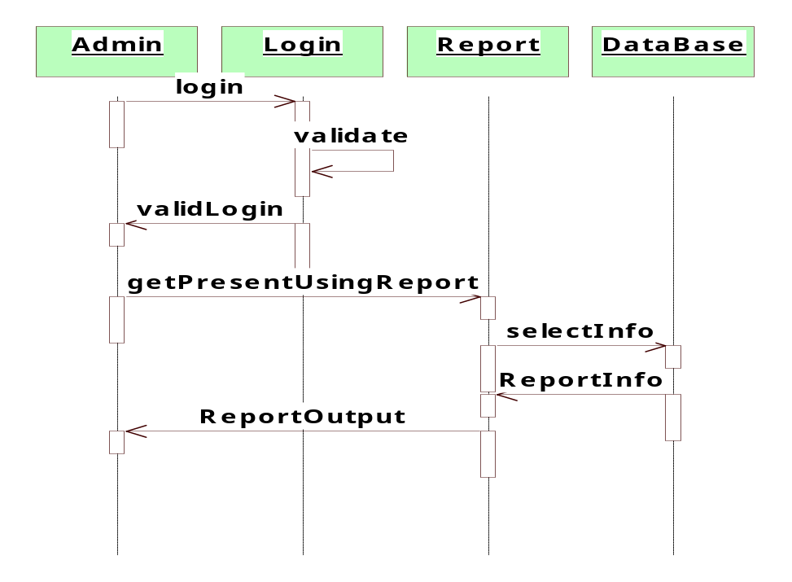
Present Login User Report Collaborative Diagram
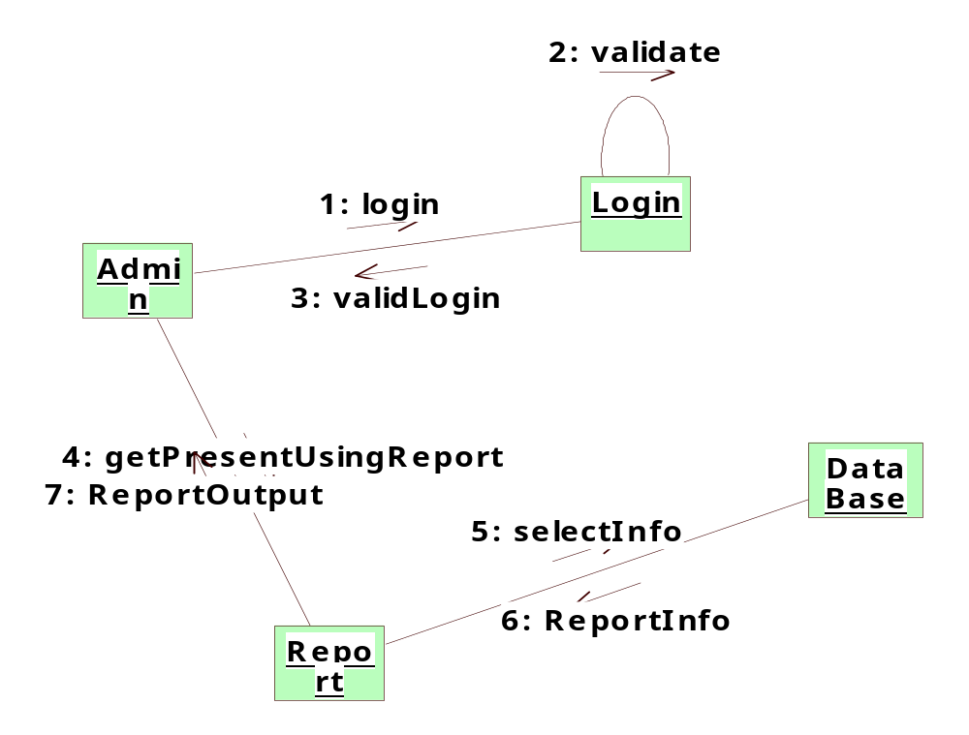

Activity Diagram

ACTIVITY DIAGRAMS

User/Administrator Activity Diagram:
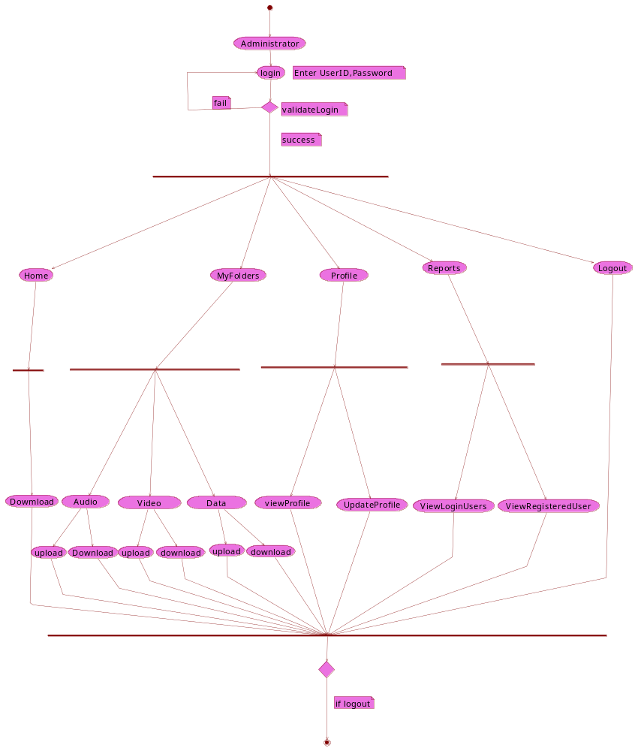

Upload Activity Diagram:

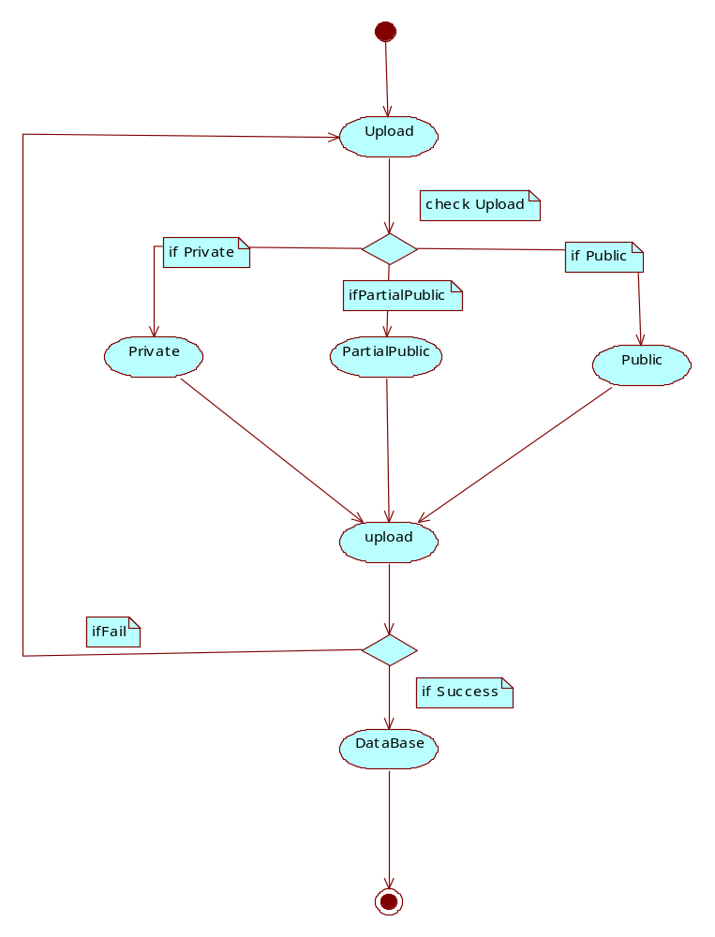

Download Activity Diagram:
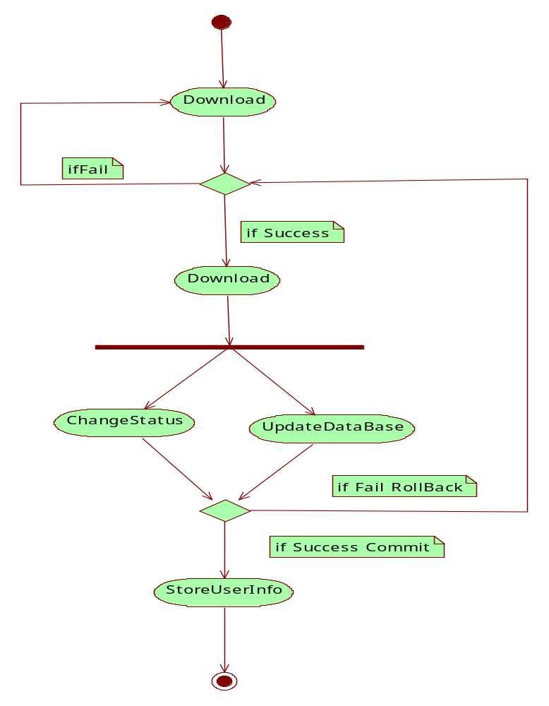

Component Diagram

Component Diagram :

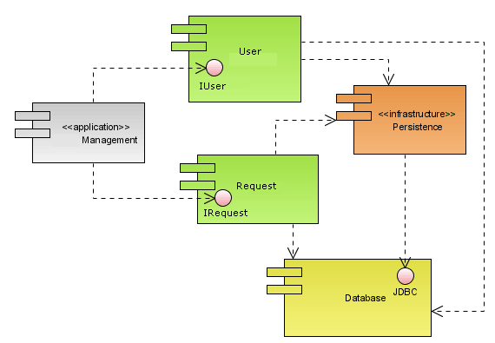

Deployment Diagram
Deployment Diagram:

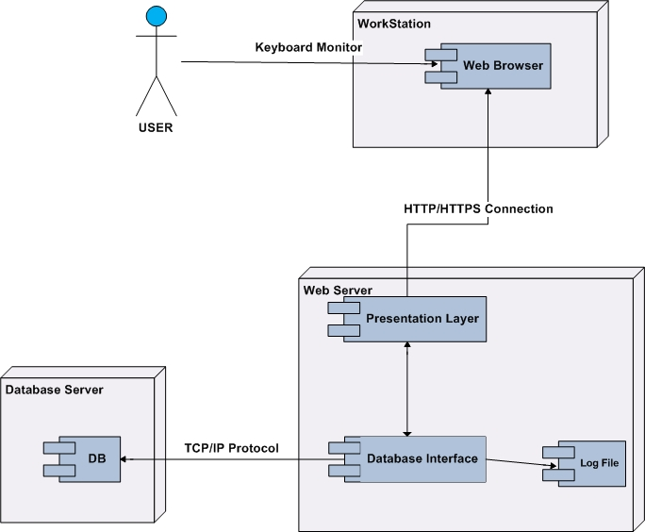

Data Dictionary

Data Dictionary

ADDRESSES

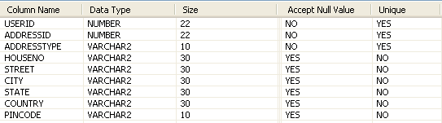

FILEDOWNLOAD

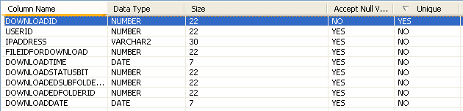

FILETYPE

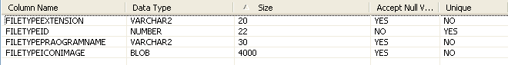

FILEUPLOAD

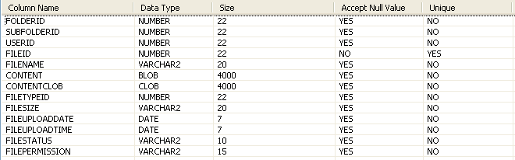

LOGINACTIVITY

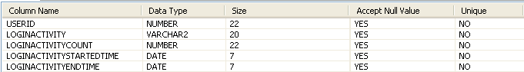

LOGINMASTER

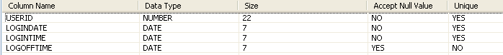

PARTIALPUBLICFILESTATUS

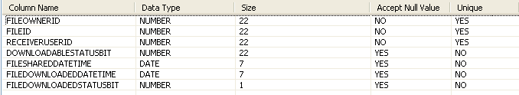

PERSONALFOLDER

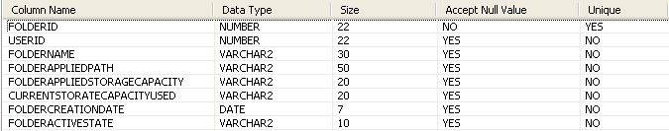

PHONES

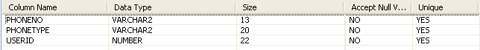

SUBFOLDER

